🏦 Salesforce Project: Bank Management App

Create an app in salesforce simulating the functionalities of a Bank (App Label: “Bank”).
👉 Setup → App Manager → New Lightning App
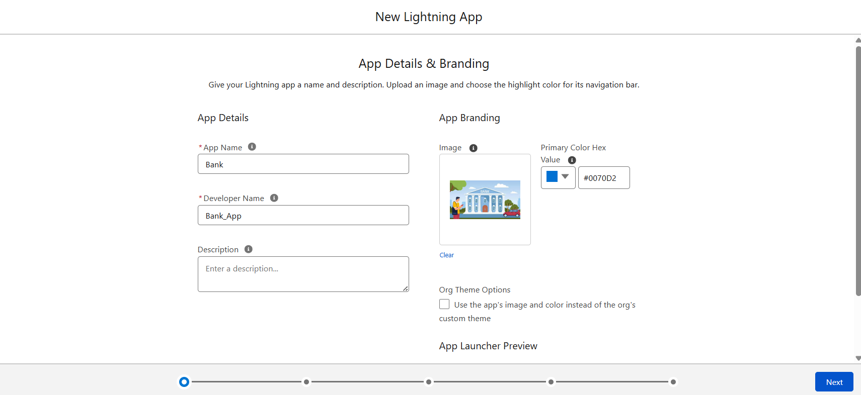

It should have following tables to store data Bank, Branch, Account, Loan, Loan Detail and transaction.

1.Bank Object
Setup → Object Manager → Create → Custom Object
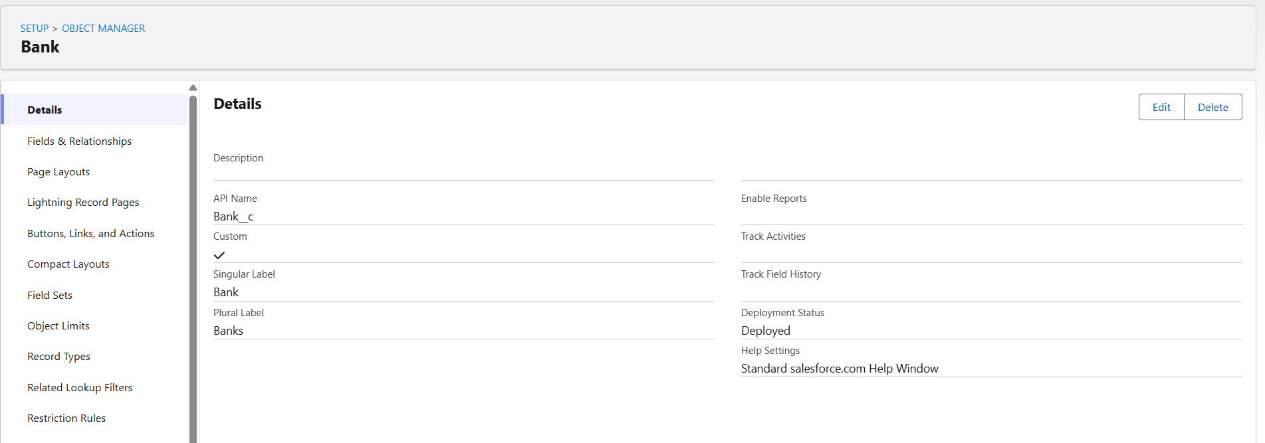

2. Branch Object
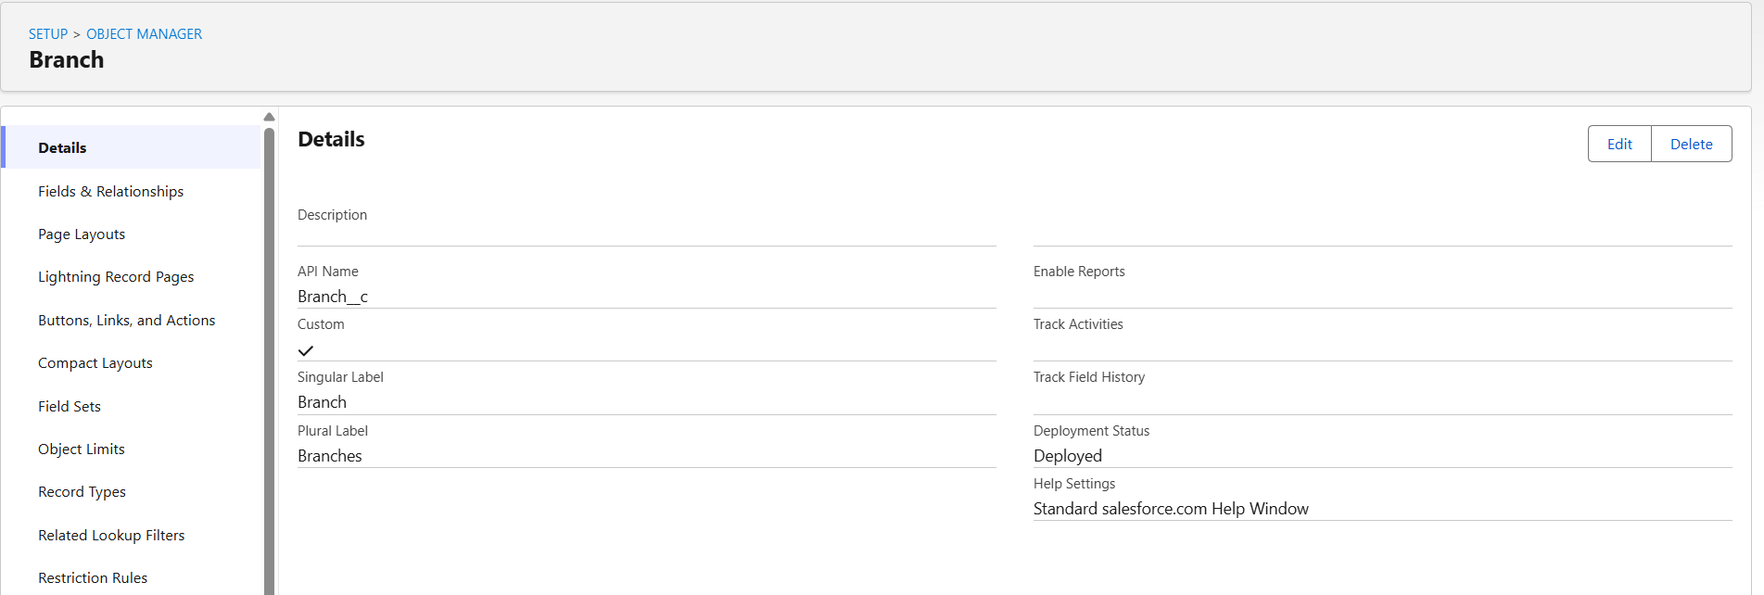

3. Account Object
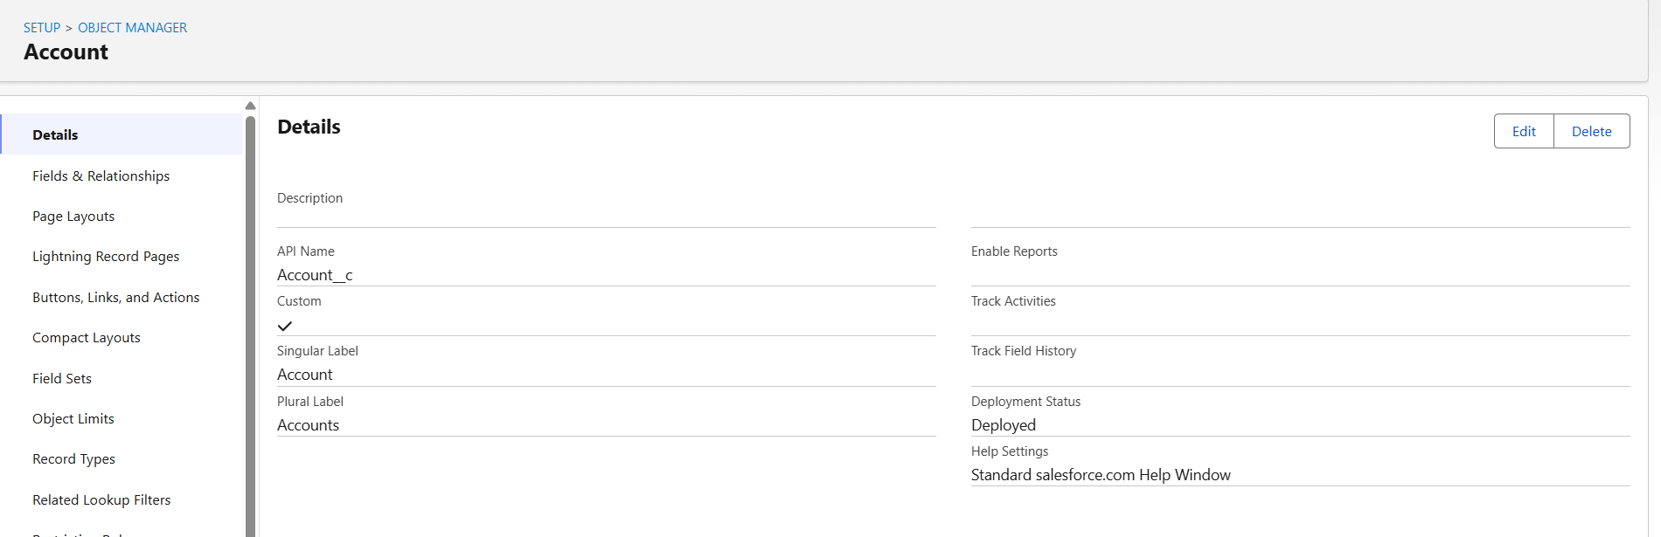

4. Loan Object
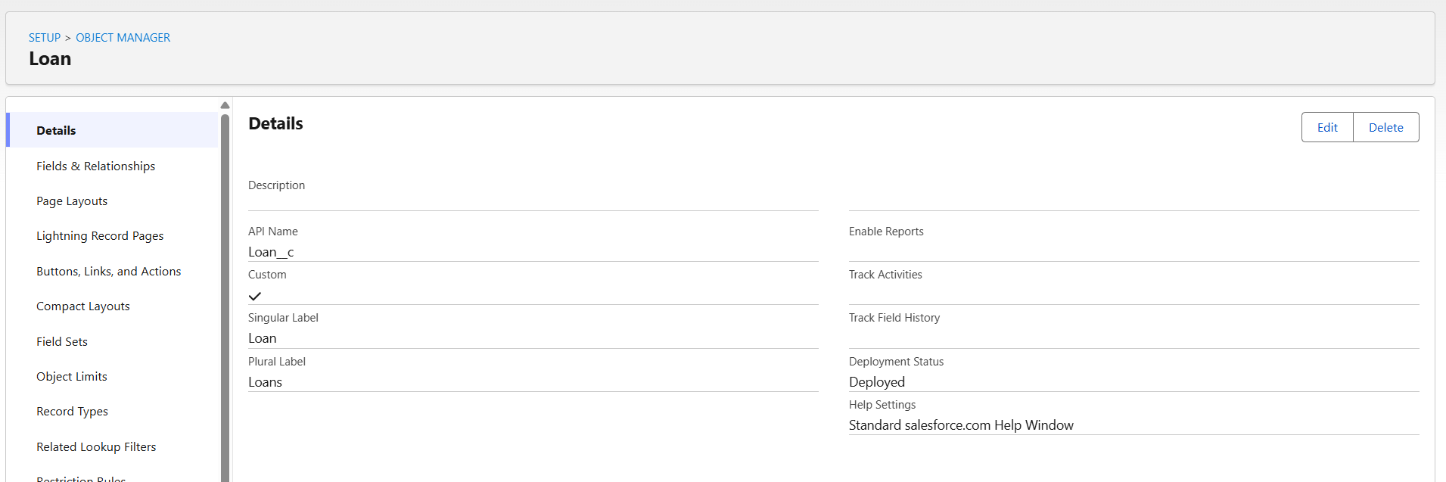

5. Loan Detail Object
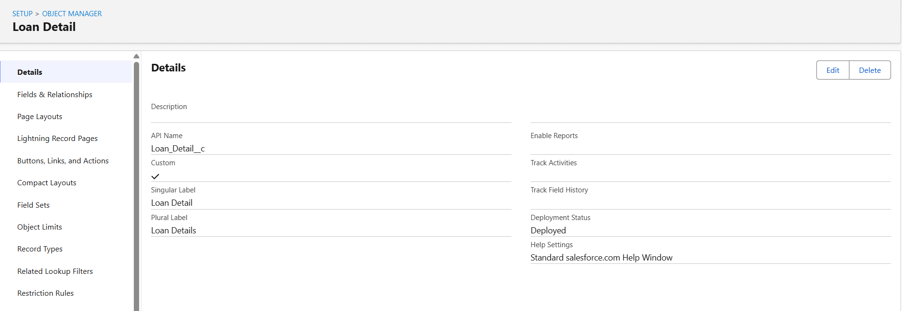

6. Transaction Object
